**Streamlining Ticket Assignment for Efficient Support Operations**

**Team Id:** **NM2025TMID15059**

**Team Members:**

**Team Leader: UKAENTHIRAN K**

**Team Member 1 : GIRITHARAN K**

**Team Member 2 : VALLAN P**

**Team Member 3 : VIJAY M**

**Problem : Streamlining Ticket Assignment for Efficient Support Operations**

**Statement:**

In support operations, ticket assignment is often done manually or through inefficient processes, leading to delays, uneven workload distribution, and reduced customer satisfaction. Without a streamlined system, support agents may face confusion, repetitive tasks, and lack of prioritization in handling issues. This results in slower resolution times, higher operational costs, and difficulty in tracking accountability. Therefore, there is a need for an efficient, automated, and intelligent ticket assignment system that ensures fair distribution of tasks, improves response times, and enhances overall support efficiency.

**Objective:**

1. To design and implement an automated ticket assignment system that reduces manual effort and delays.
2. To ensure fair and balanced distribution of tickets among support agents based on workload, expertise, and priority.
3. To minimize resolution time by intelligently routing tickets to the most suitable agent or team.
4. To improve customer satisfaction through faster and more efficient issue handling.
5. To provide real-time monitoring and reporting for better transparency and accountability in support operations.
6. To optimize operational efficiency by reducing repetitive tasks and enhancing agent productivity.

**Skills:**

Gained knowledge in ServiceNow ticketing, workflow automation, and incident management. Learned to use Flow Designer, scripting (JavaScript), and reporting for efficient ticket assignment. Developed analytical, problem-solving, and teamwork skills to improve support operations.

**TASK INITIATION**

**Milestone 1 : Users**

**Activity 1: Create Users**

1. Open service now.
2. Click on All  >> search for users
3. Select Users under system security
4. Click on new
5. Fill the following details to create a new user
6. Click on submit

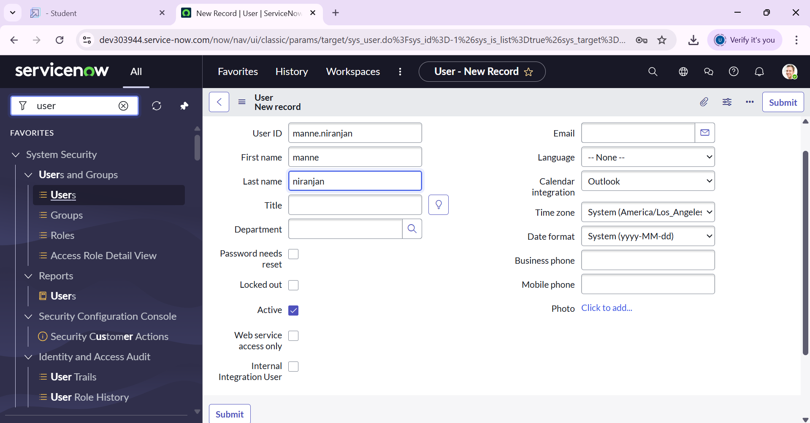

# Create one more user:

1. Create another user with the following details
2. Click on submit

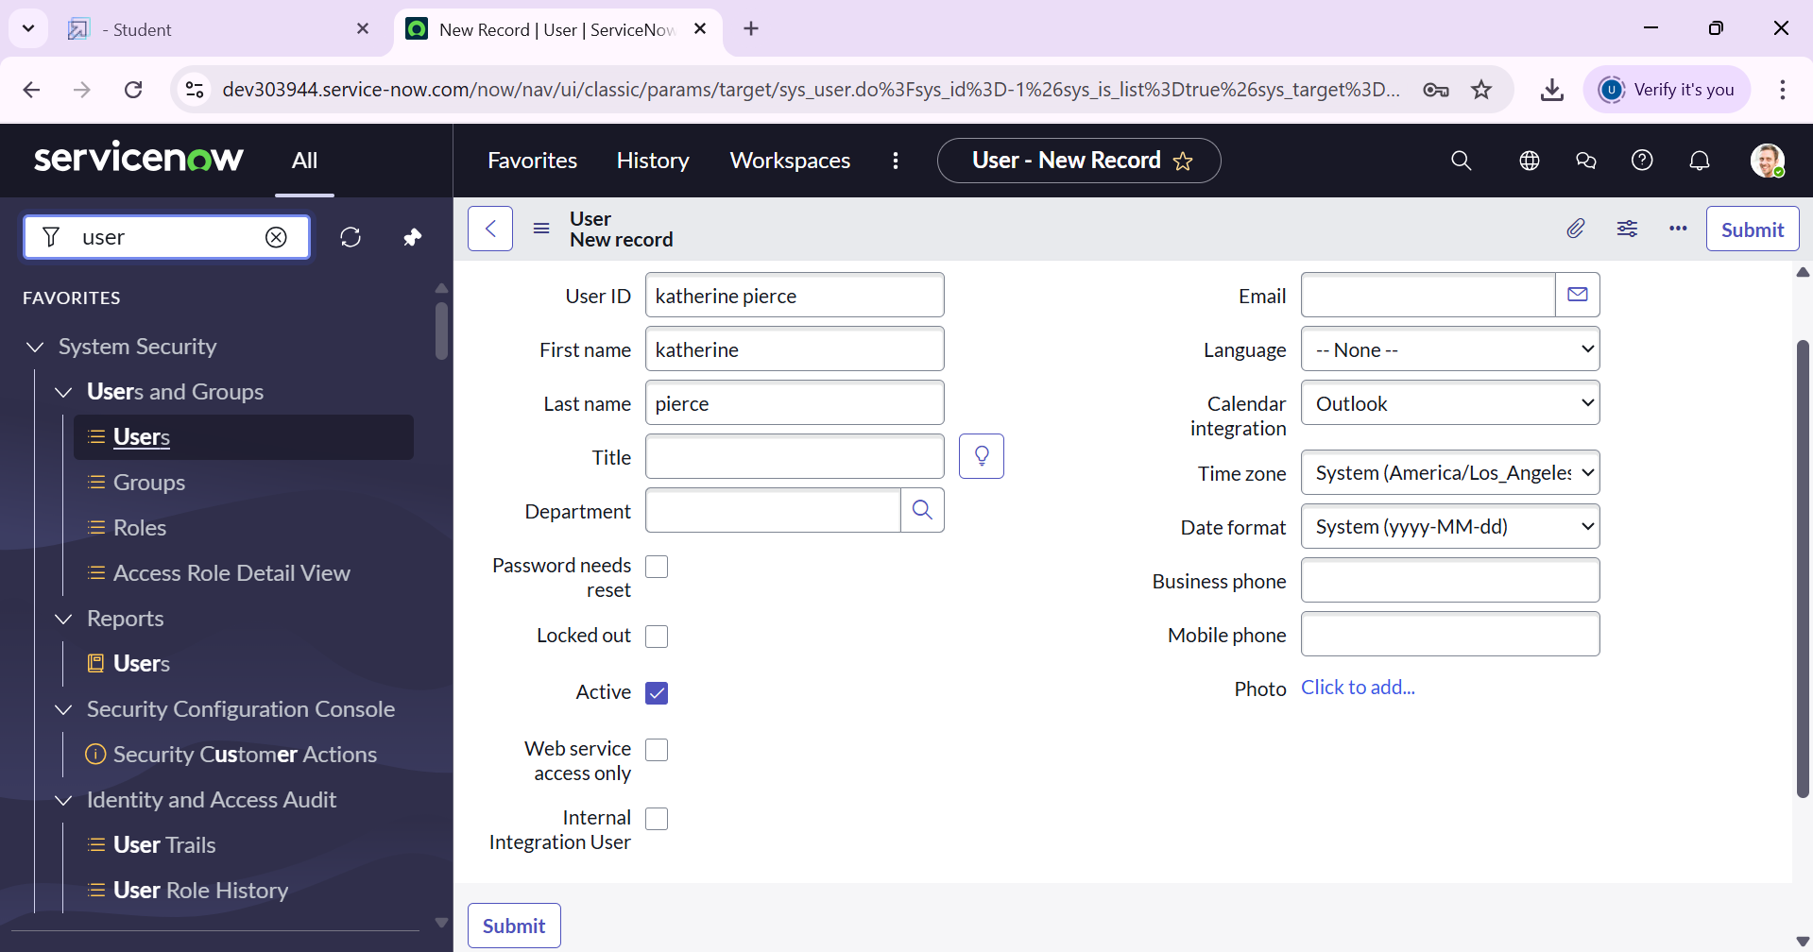

**Milestone 2 : Groups**

**Activity 1: Create Groups**

1. Open service now.
2. Click on All  >> search for groups
3. Select groups under system security
4. Click on new
5. Fill the following details to create a new group
6. Click on submit

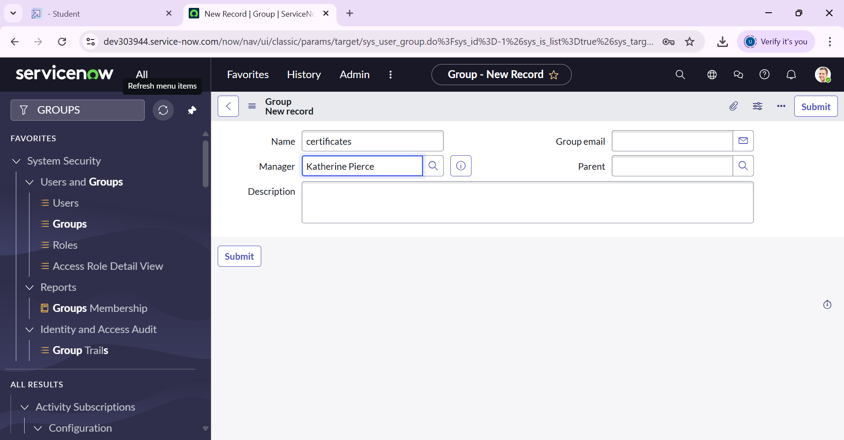

# Create one more user:

1. Create another user with the following details
2. Click on submit

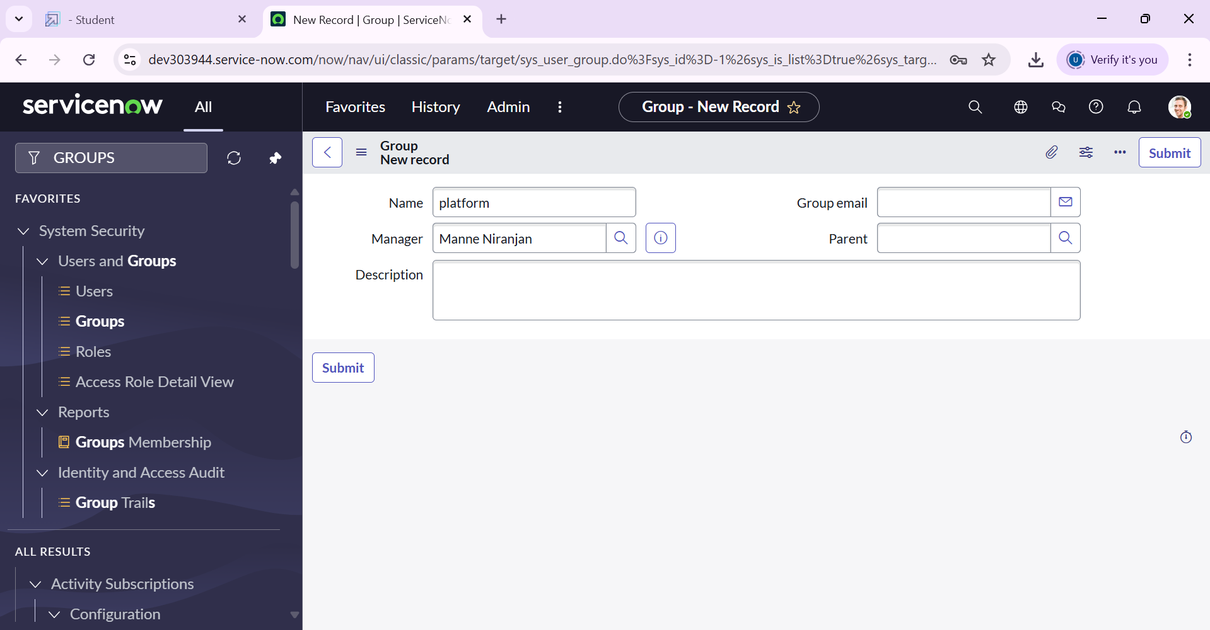

**Milestone 3 : Roles**

**Activity 1: Create roles**

1. Open service now.
2. Click on All  >> search for roles
3. Select roles under system security
4. Click on new
5. Fill the following details to create a new role
6. Click on submit

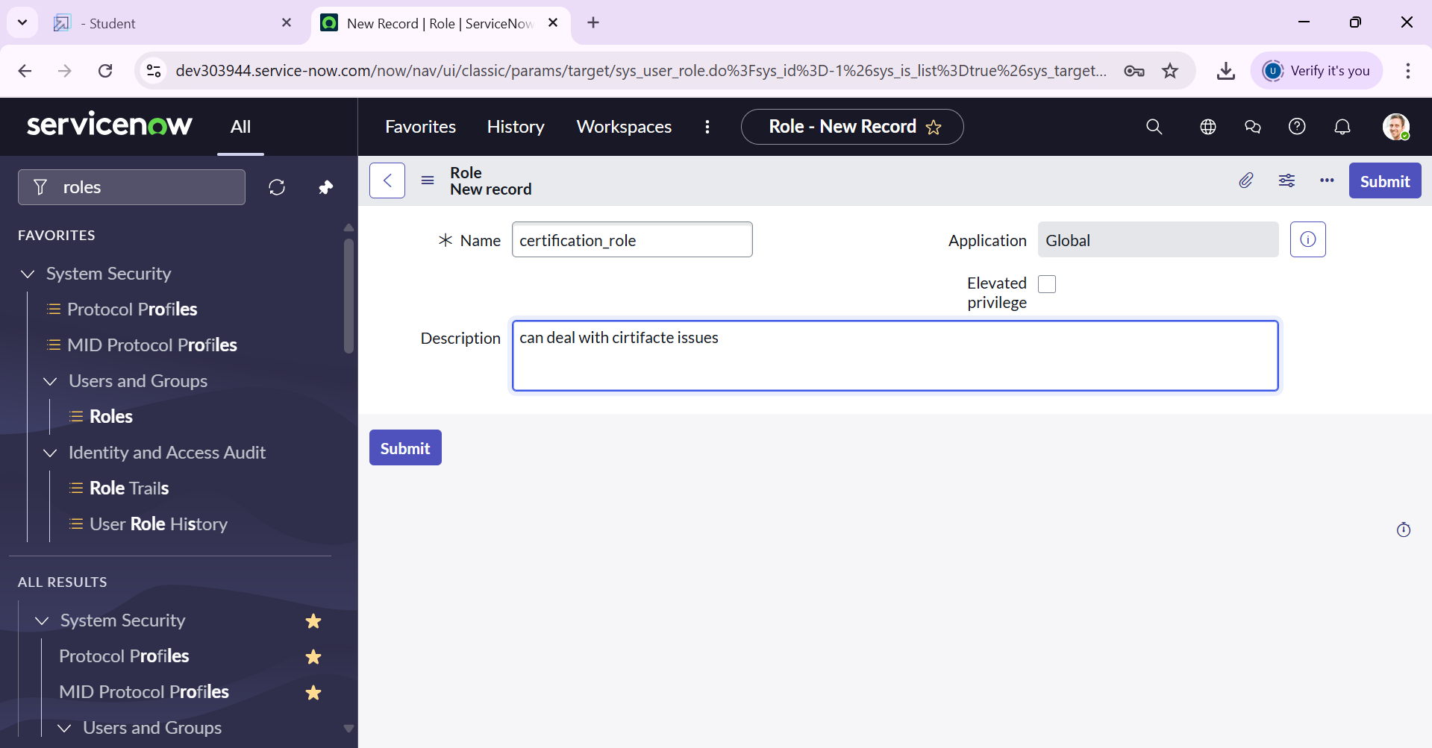

# Create one more role:

1. Create another role with the following details
2. Click on submit

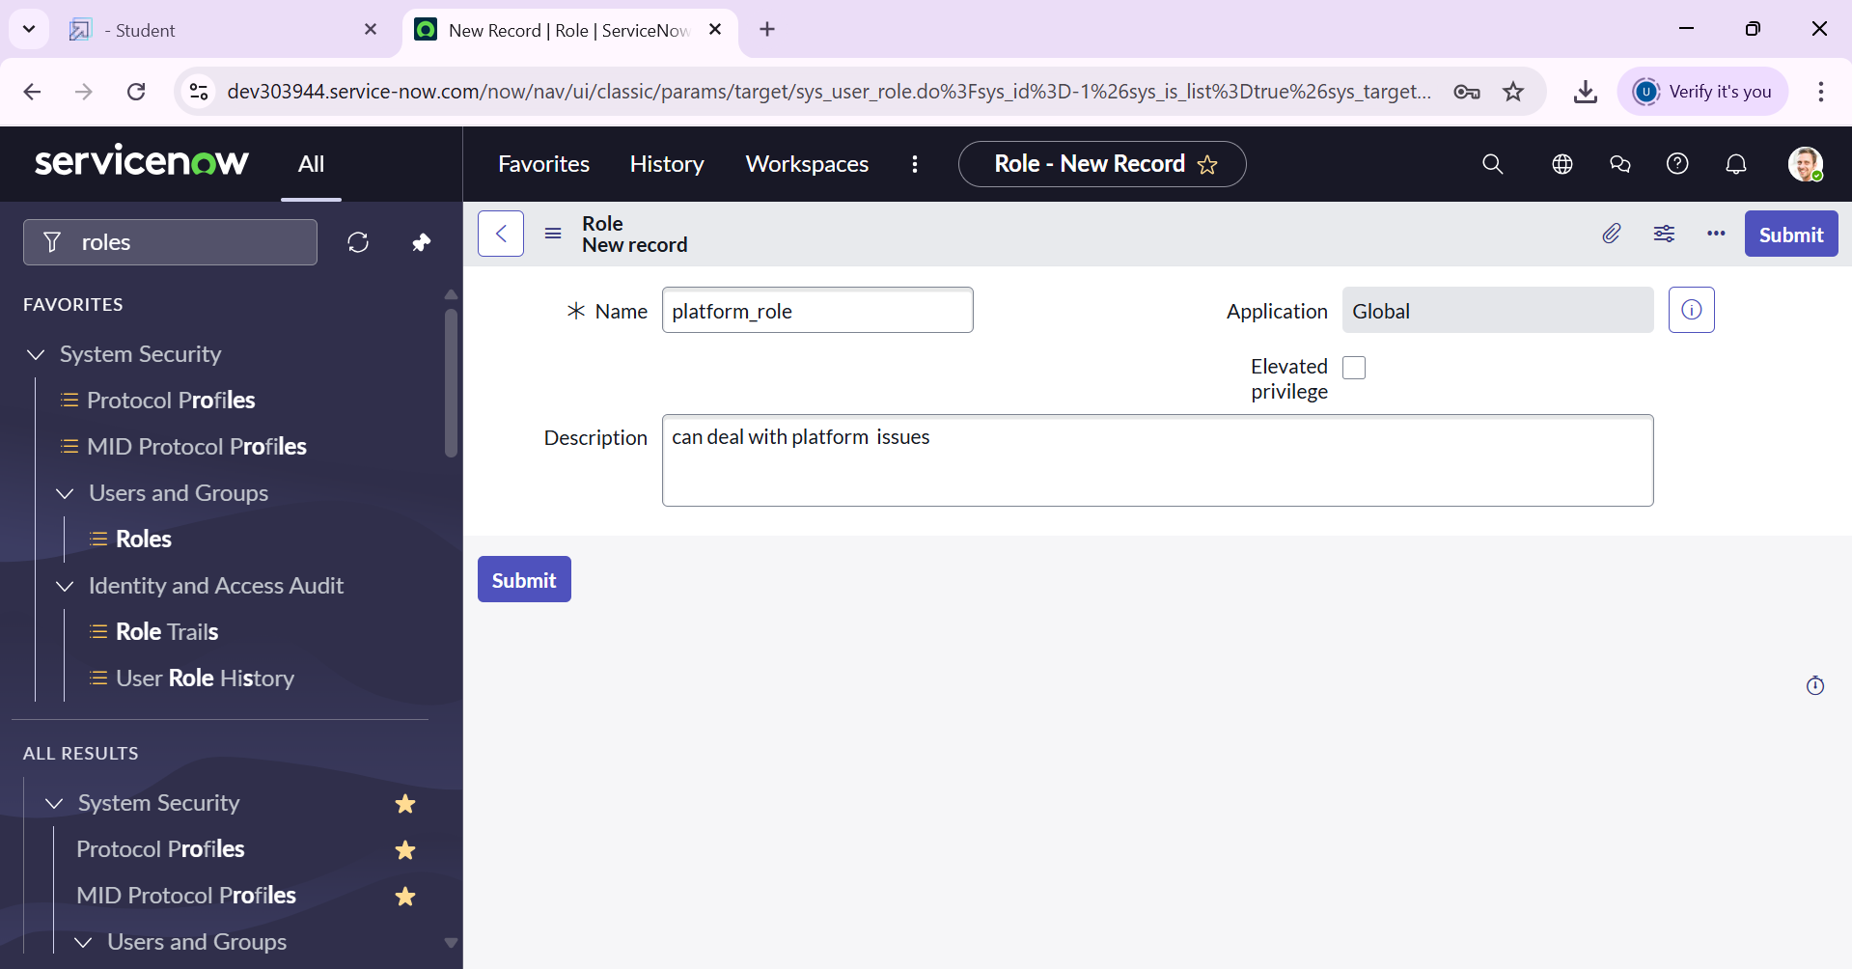

**Milestone 4 : Table**

**Activity 1: Create Table**

1. Open service now.
2. Click on All  >> search for tables
3. Select tables under system definition
4. Click on new
5. Fill the following details to create a new table  
   Label : Operations related  
   Check the boxes Create module & Create mobile module
6. Under new menu name : Operations related
7. Under table columns give the columns
8. Click on submit

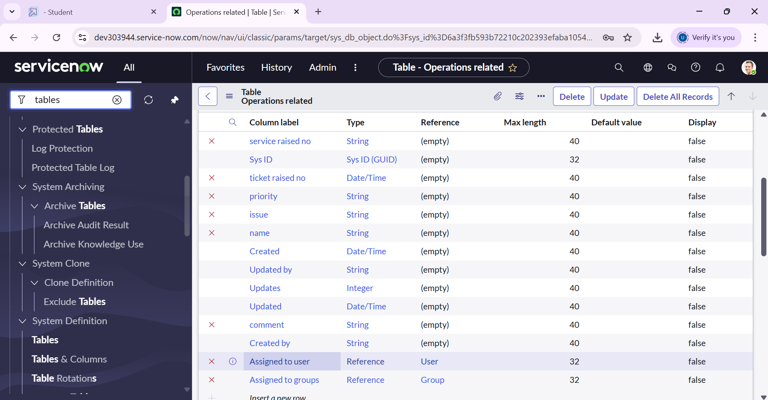

**Milestone 5: Assign Roles & users to group**

**Activity 1: Assign roles & users to certificate group**

1. Open service now.
2. Click on All  >> search for tables
3. Select tables under system definition
4. Select the certificates group
5. Under group members
6. Click on edit
7. Select Katherine Pierce and save
8. Click on roles
9. Select Certification_role and save

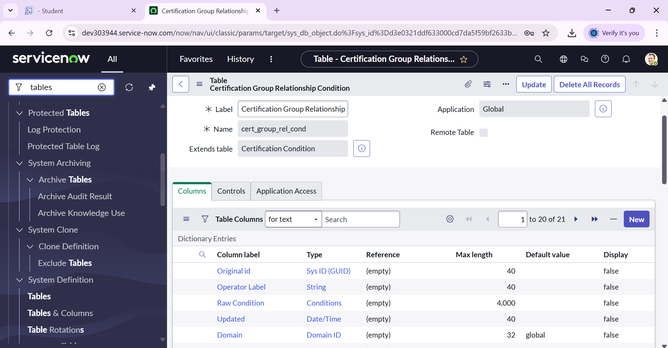

**Activity 2: Assign roles & users to platform group**

1. Open service now.
2. Click on All  >> search for tables
3. Select tables under system definition
4. Select the platform group
5. Under group members
6. Click on edit
7. Select Manne Niranjan and save
8. Click on roles
9. Select Platform_role and save

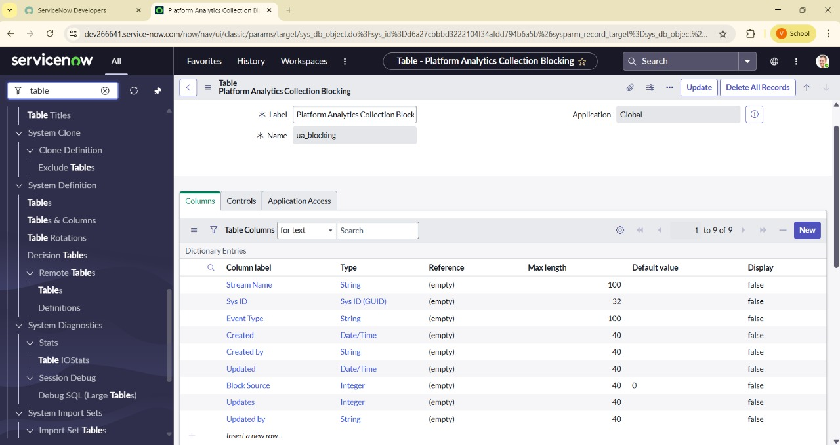

**Milestone 6 : Assign role to table**

**Activity 1: Assign role to table**

1. Open service now.
2. Click on All  >> search for tables
3. Select operations related table
4. Click on the Application Access
5. Click on u_operations_related read operation
6. Click on the profile on top right side
7. Click on elevate role
8. Click on security admin and click on update
9. Under Requires role
10. Double click on insert a new row
11. Give platform role
12. And add certificate role
13. Click on update
14. Click on u_operations_related write operation
15. Under Requires role
16. Double click on insert a new row
17. Give platform role
18. And add certificate role

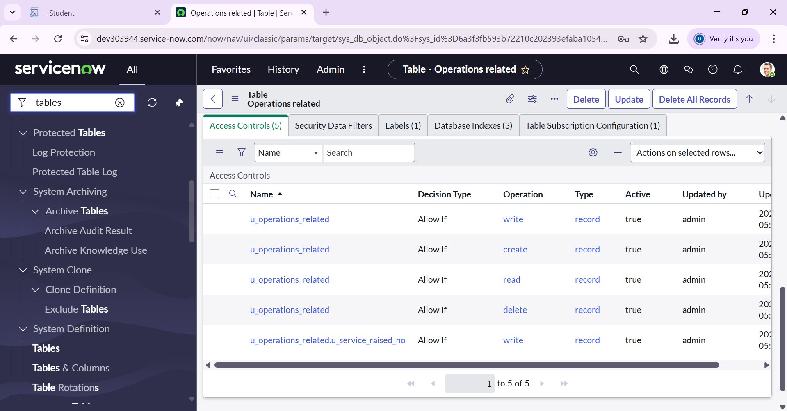

**Milestone 7 : Create ACL**

**Activity 1: Create ACL**

1. Open service now.
2. Click on All  >> search for ACL
3. Select Access Control(ACL) under system security
4. Click on new
5. Fill the following details to create a new ACL
6. Scroll down under requires role
7. Double click on insert a new row
8. Give admin role
9. Click on submit
10. Similarly create 4 acl for the following fields

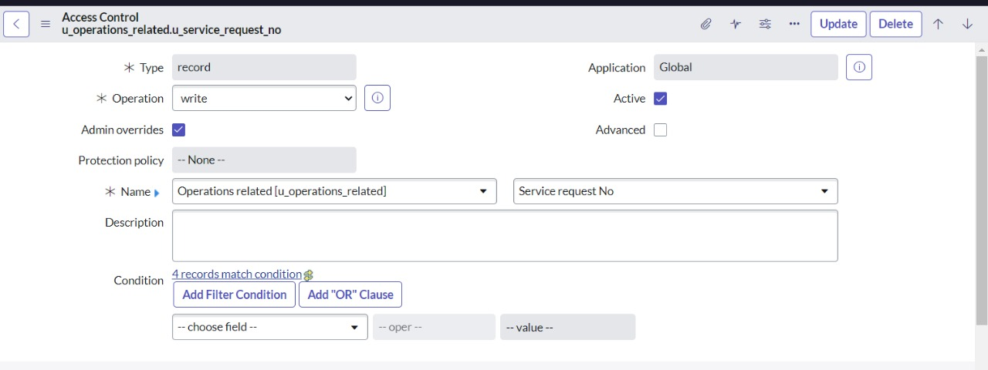

**Milestone 8: Flow**

**Activity 1: Create a Flow to Assign operations ticket to group**

1. Open service now.
2. Click on All  >> search for Flow Designer
3. Click on Flow Designer under Process Automation.
4. After opening Flow Designer Click on new and select Flow.
5. Under Flow properties Give Flow Name as “ Regarding Certificate”.
6. Application should be Global.
7. Select Run user as “ System user ” from that choice.
8. Click on Submit.
9. Click on Add a trigger
10. Select the trigger in that Search for “create or update a record”  and select that.
11. Give the table name as “ Operations related ”.
12. Give the Condition as  
    Field : issue

Operator : is

Value : Regrading Certificates

1. After that click on Done
2. Now under Actions.
3. Click on Add an action.
4. Select action in that search for “ Update Record ”.
5. In Record field drag the fields from the data navigation from left side
6. Table will be auto assigned after that
7. Give the field as “ Assigned to group ”
8. Give value as “ Certificates ”
9. Click on Done.
10. Click on Save to save the Flow.
11. Click on Activate.

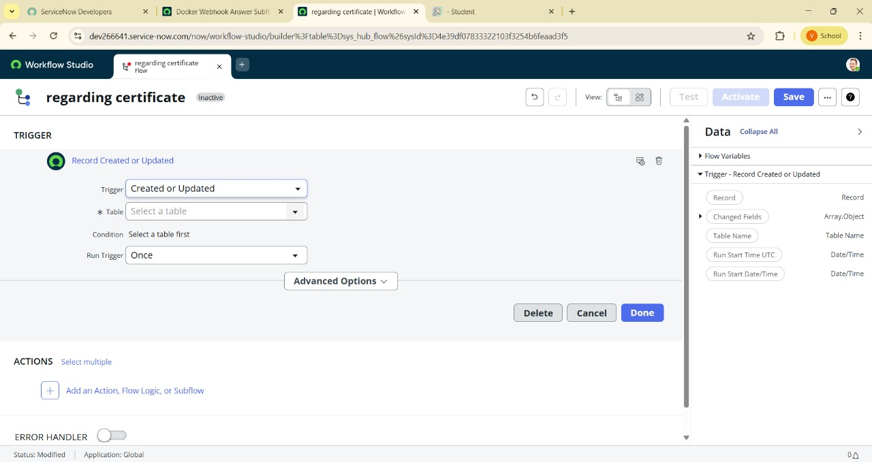

**Activity 2: Create a Flow to Assign operations ticket to Platform group**

1. Open service now.
2. Click on All  >> search for Flow Designer
3. Click on Flow Designer under Process Automation.
4. After opening Flow Designer Click on new and select Flow.
5. Under Flow properties Give Flow Name as “ Regarding Platform ”.
6. Application should be Global.
7. Select Run user as “ System user ” from that choice.
8. Click on Submit.

1. Click on Add a trigger
2. Select the trigger in that Search for “create or update a record”  and select that.
3. Give the table name as “ Operations related ”.
4. Give the Condition as  
   Field : issue

Operator : is

Value : Unable to login to platform

1. Click on New Criteria

Field : issue

Operator : is

Value : 404 Error

1. Click on New Criteria

Field : issue

Operator : is

Value : Regrading User expired

1. After that click on Done.
2. Now under Actions.
3. Click on Add an action.
4. Select action in that search for “ Update Record ”.
5. In Record field drag the fields from the data navigation from left side
6. Table will be auto assigned after that
7. Give the field as “ Assigned to group ”.
8. Give value as “ Platform ”.
9. Click on Done.
10. Click on Save to save the Flow.
11. Click on Activate.



**Conclusion :**

The project “Streamlining Ticket Assignment for Efficient Support Operations” showed how ServiceNow can make ticket handling faster and easier. By using automation and smart ticket routing, it reduced manual work, saved time, and shared tasks fairly among support agents. This made the support process smoother and improved customer satisfaction. Through this project, we also gained hands-on experience with ServiceNow, scripting, and workflow design, which will be useful for solving real IT service problems in the future